Steps to install the Natural Reader Text to Speech Extension to the Google Chrome Browser
Open the Chrome Browser by going to the search bar or clicking on the Windows ‘Start’ button and typing Chrome.
The Chrome app should appear at the top of the preferred application list. Click the app to open it.
In the Chrome address bar, type in:
https://chrome.google.com/webstore/search/ and then press the ‘Enter’ key.
When the Chrome Store search page opens, Type ‘Natural Reader’ into the search bar at the left:
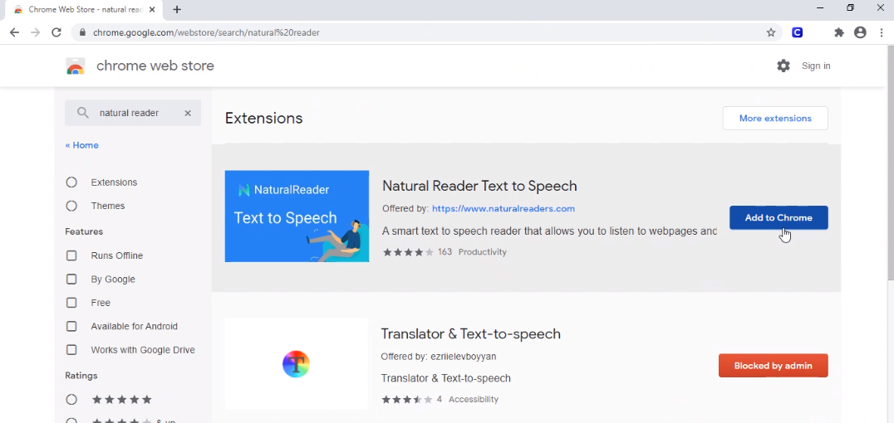
The Natural Reader Text to Speech plugin should be listed first with a button ‘Add to Chrome’.
Click that button.
NOTE: If the button is marked ‘Blocked by admin’, you will need to fully restart your computer, ensure that Global Protect is properly connected and login to the computer. This process should allow the security policy to update for Chrome and allow this plugin to be added.

After clicking the ‘Add to Chrome’ button, you will be prompted with the pop-up notice shown below:
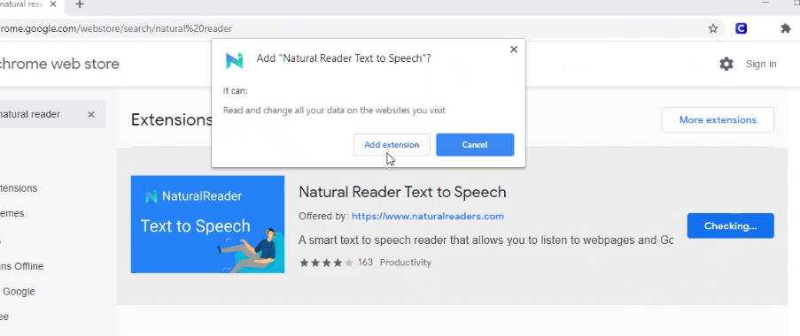
Click on the ‘Add extension’ button.
The extension will install, and the browser will open a new tab to the Natural Reader website. You can ignore the button on that page labeled ‘Add to chrome’. Click on the original tab for the Chrome Web Store. You should see the button for Natural Reader Text to Speech has changed to a ‘Rate it’ button.
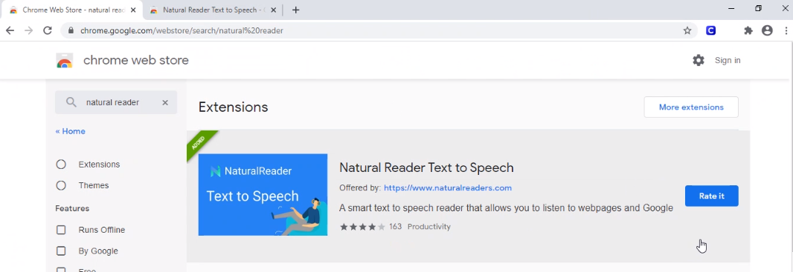
This is your indication that the plugin has been installed and is now available for use within the Chrome browser.

