How to fix sounds being low on the 5410.

Right click on the sound icon to open sound settings.
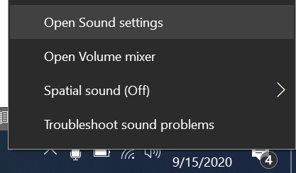
Click Device Properties.
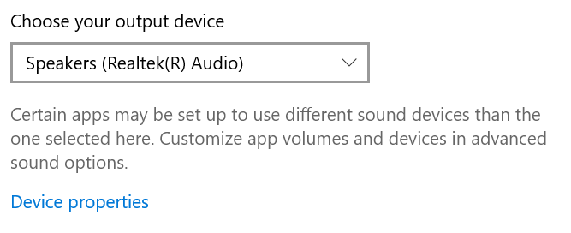
Click Additional Device Properties at the bottom of the window.
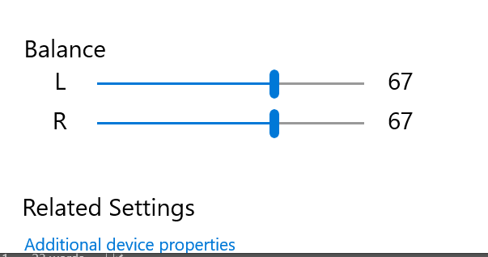

Click the Advanced Tab at the top
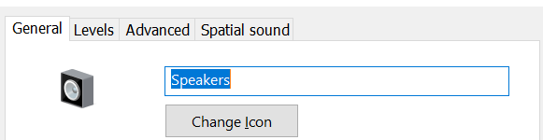
Uncheck the box for “Enable audio enhancements”
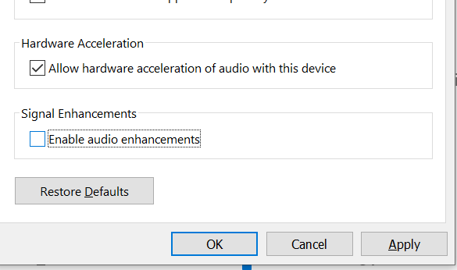
Hit OK.

Issue should now be fixed.

