Google Drive & Docs IMPORTANT info
Ms. Williams
How do I log in to my account?
- Go to www.google.com
- Login with your gmail account
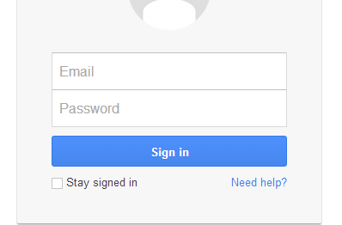
How do I find Google Drive?
- Click the little grid in the upper right corner

- Then click the Google Drive symbol
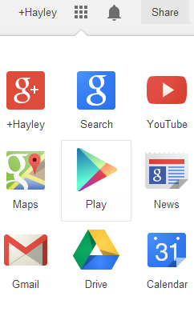

- You will then be able to see your folders
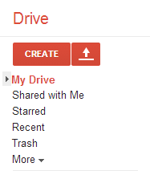
If you select “My Drive” this will be all of your personal documents. This is where you should store and organize your work.

If you select “Shared with Me” this will open up any documents that a teacher or peer has shared with you. This is where you will access any original assignment from me (Ms. Williams)

How do I create a folder in My Drive?

- Click the “Create” button and select folder

- You will then be prompted to create a name for your folder

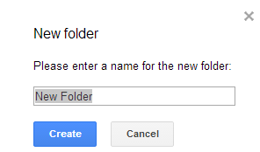

- I would recommend titling your first folder with a broad name, such as “Personal Finance” or “Computer Technology” (depending on which class you are in). You can then make smaller subfolders to help keep you organized.
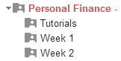

- To create the subfolders, you will repeat the process of creating a new folder. If when you create a folder an existing folder is already open and its contents are displayed, then the new folder will be created as a sub-folder inside this. Once you have a folder it is simple to drag documents into it.
How do I move existing folders into other folders ?
- If you did not create the folder while an existing folder is open and you want it to be a subfolder, you will click the box next to the name of the folder you created. The selected folder will highlight yellow. You will then click the “More” button.

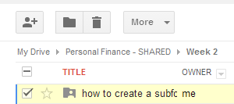
Click the More button here. You will then select “Move to” from the dropdown options.

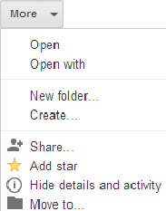
“Move to” button

- You then select the desired area that you want to move the folder to.
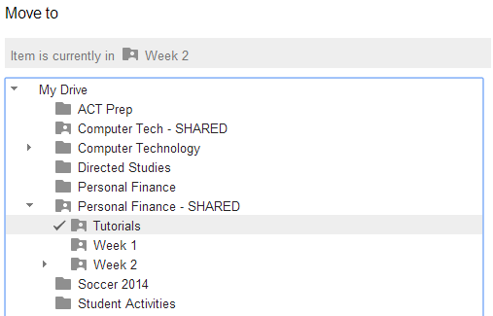
I chose move mine to “tutorials” therefore there is a check mark next to it.

How do I access the “Shared” folder to find my assignments?
- You will click “Shared with me”
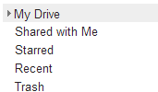

- You will then see any folders/files that your teachers have shared with you. For my class, you will look for “Personal Finance” or “Computer Technology”

- You will then see the subfolders. I have organized your assignments into weekly folders. Click on the corresponding week to access the documents.

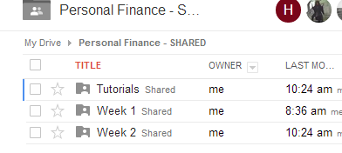

- I will have all of your assignments numbered so that you will know where they belong in your paper assignment folder for my class. You will then click the assignment for the day.

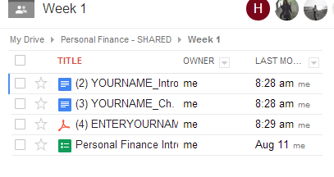

How do I open and edit my assignment?
THIS IS A VERY IMPORTANT PROCESS. PLEASE PAY CLOSE ATTENTION TO DETAIL.

- Google Docs allows you to open documents in either a Microsoft word format or in an editable Google Docs format. For class, we need to use Google Docs so that we don’t have to store info on school computers.

- For this example, I am choosing assignment number 2 to edit.
- You will notice that the document opens in a new tab, and that it says “VIEW ONLY”
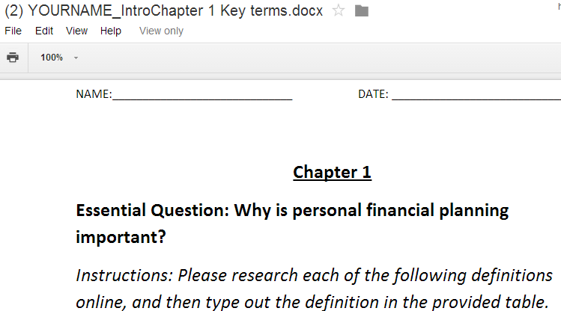

- You will then click the “File” option, and then click “Make a copy”

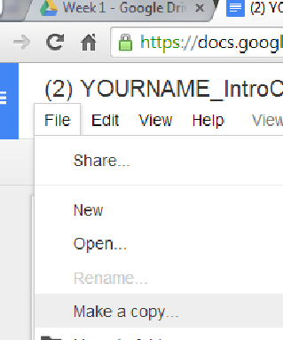
- Please follow this format for EVERY assignment when renaming. Leave the assignment numbered and named as I have labeled it. This will help you stay organized. Simply replace the “YOURNAME” with your actual name. Please use your real name.

So, if the original document was:

  - (2) YOURNAME_IntroChapter1KeyTerms

*you would change it to*

  - (2) JOHNDOE_IntroChapter1KeyTerms

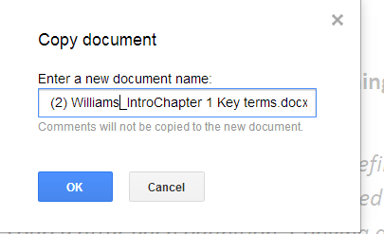

- You now have a document that can be edited and INSTANTLY saved in Google Drive. EDIT AWAY!! This applies to Docs, PPTS, Spreadsheets, etc.

After I make a copy of a saved doc, where in the world does it go?
- While you are editing the document, all changes will automatically save. You will need to choose where to save your file. You will simply click to “File” button in the upper left corner, and then click “Move to” in order to move it to your desired folder.

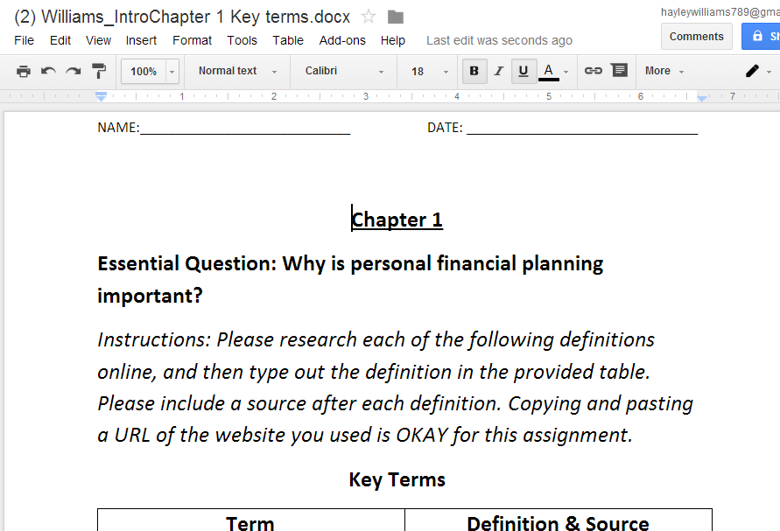

What happens if I forgot to move my doc to a folder? Where is it?
- No need to worry! Anytime you forget where you stored an item, you can find it under “More” and then “all items”… Everything you have ever created will be located here. You can then move your doc wherever your heart desires.
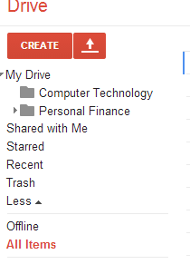
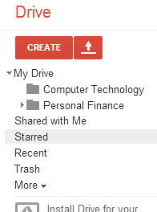

How do I upload a MS Word document from my house?
- Click the Arrow
- You will then be prompted to either upload a “file” or a “folder” … most of the time you will be uploading a file. You will then select the desired file from your computer and click “Open”
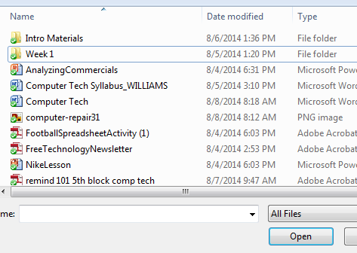
- Depending on your settings, you can either upload the document as an original Microsoft Word document, or you can upload it as a Google Doc.

- This symbol means it is a Google Doc

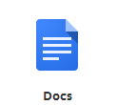

- This “W” symbol means it has been uploaded as a Word Document
Where Do I change my upload settings?
- Click the Settings button
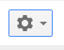

- Then click “Upload Settings”

- You can choose from several options. For my class, please make sure that “Convert uploaded files to Google docs” is selected

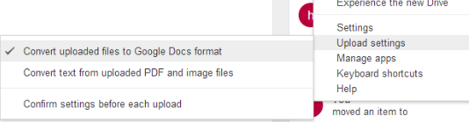

- It is generally a bad idea to convert text from an uploaded PDF, so please don’t choose this option.

